**Primary Care Access Recovery Programme Newsletter**

**19 October 2023**

This week has seen a step change in communication around some of the changes staff, partners and public can now see in primary care.

On Thursday, a campaign has launched to raise awareness and confidence in members of the wider general practice team – for instance receptionist, social prescriber, physio, paramedic and mental health practitioner.

The work includes a film to be shown on digital platforms as well as assets that regions can share on websites, with stakeholders and on social media.

It is targeted at all adults, although with more focus on working age adults, parents, older people and those with long term health conditions who are more likely to make a GP appointment.

There is also focus on those from more deprived communities, as well as co-branded partnerships with multi-cultural health associations to build understand among wider audiences who are often under-served by healthcare.

You can help by sharing the resources with partners and with GP practices. In the toolkit attached you will find links to the Campaign Resource Centre where everything is available free of charge [NHS General Practice Team | Help Us Help You - Primary Care Services | Campaign Resource Centre (dhsc.gov.uk)](https://campaignresources.dhsc.gov.uk/campaigns/help-us-help-you-primary-care/nhs-general-practice-team/)

The site is easy to register with and is available to anyone working in the NHS and with local authorities.



**Pharmacy**

Closer working between general practice and pharmacy teams is leading to expansion of services and growth in usage of pharmacy services in the Midlands.

Over the last two months almost 20,000 GP Community Pharmacist Consultation Service (GP CPCS) consultations have taken place, where a surgery has referred a patient to a local pharmacist for consultation and possible treatment. [NHS England — Midlands » NHS Community Pharmacist Consultation Service (CPCS)](https://www.england.nhs.uk/midlands/nhs-england-and-nhs-improvement-midlands-work/nhs-community-pharmacist-consultation-service-cpcs/)

The number of pharmacies supporting the Extended Services such as treatment for UTIs in women aged 16-64 and conjunctivitis for children under the age of two continues to increase with 21 new pharmacies signing up this month alone. [NHS England — Midlands » Community Pharmacy Extended Care Services](https://www.england.nhs.uk/midlands/nhs-england-and-nhs-improvement-midlands-work/community-pharmacy-extended-care-services/)

The number of oral contraception consultations by pharmacists has doubled over the last month to 439 and the number of blood pressure checks has increased to more than 34,300. [NHS England — Midlands » Pharmacy contraception service](https://www.england.nhs.uk/midlands/nhs-england-and-nhs-improvement-midlands-work/pharmacy-contraception-service/)

Look out for details of an oral contraception webinar designed to allow pharmacists to ask questions about the service on Thursday 28 November.

This is all ahead of the completion of negotiations on the Common Conditions Service which is due to start in the New Year.

**Contracting**

This month ICBs begin the presentation of their Primary Care Access Recovery Programme plans to their public boards.

Some systems are sending through their plans for comment. If you would like to do so, please send through to [midlands.pctransformation@nhs.net](mailto:midlands.pctransformation@nhs.net) with details of your deadline.

The second questionnaire circulated to systems to assess progress and challenges have now been received. Analysis is prioritising the primary and secondary care interface and results will be shared through the peer access meetings.

**Digital**

At the end of this month the NHS is giving people access to their GP record on the NHS App, NHS website and other online services. This means people will be able to easily access information including consultation notes, test results and letters.

A toolkit to help ICBs and GP practices raise awareness of this among patients is here [Accessing your GP health record through the NHS App - supporting materials - NHS Digital](https://digital.nhs.uk/services/nhs-app/toolkit/patient-communications-for-practices/supporting-materials)

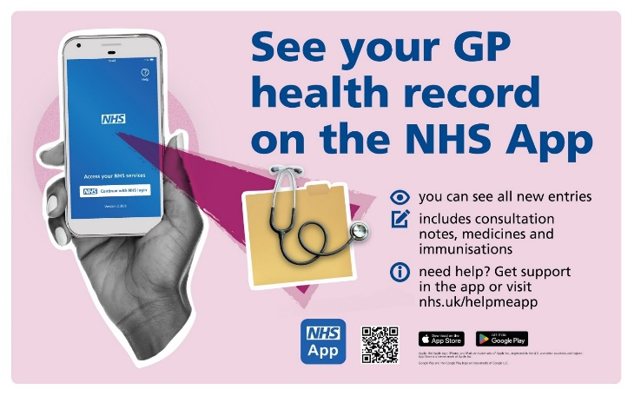GP practices should be ready for this, but please make sure that there are enough practices able to offer access before promoting more widely to your own networks.

**Communications**

Regional support will be given to the NHS General Practice Team amplifying the national work [NHS General Practice Team | Help Us Help You - Primary Care Services | Campaign Resource Centre (dhsc.gov.uk)](https://campaignresources.dhsc.gov.uk/campaigns/help-us-help-you-primary-care/nhs-general-practice-team/)

We will continue to support the pharmacy services promoting oral contraception and extended services. [NHS England — Midlands » Pharmacy contraception service](https://www.england.nhs.uk/midlands/nhs-england-and-nhs-improvement-midlands-work/pharmacy-contraception-service/) and [NHS England — Midlands » Community Pharmacy Extended Care Services](https://www.england.nhs.uk/midlands/nhs-england-and-nhs-improvement-midlands-work/community-pharmacy-extended-care-services/)

.